BCG Case Interview Guide
Meta description: WSG founder Stephen Turban breaks down the BCG case interview: the CCA and Casey screens, a full worked case, scoring, the 2027 calendar and a four-week plan.

The interviewer finishes reading the prompt, sets the page face down, and says, "So, how would you approach this?" Then nothing. At ten seconds you're still writing the last number down. At twenty you realize she isn't going to add a hint, a chart, or a first question. At forty you've drawn three boxes and the fourth one won't come. At fifty-five you look up and start talking, and whatever comes out of your mouth in the next minute is the BCG case interview. Everything after it follows from that first structure.

I'm Stephen Turban, founder of WSG. I went through McKinsey's on-cycle recruiting after Harvard and sat in that silence more than once, except at McKinsey the interviewer eventually fills it with the next scripted question. At BCG nobody fills it. What I know about BCG comes from the WSG students we coach into the firm every cycle and from what BCG itself publishes, and I re-checked every structural fact below against careers.bcg.com this week.

This guide covers the whole funnel: the two online screens, what BCG says it scores, how to use those first sixty seconds, a full case worked from prompt to recommendation with the math shown, the behavioral half, the Summer 2028 calendar, and a four-week prep plan.

How is the BCG case interview different from McKinsey's?
BCG runs candidate-led cases: you choose what to analyze next, and the interviewer mostly lets you. At McKinsey the interviewer walks you through fixed steps in a set order; at BCG you lay out a structure, say which branch you'd open first and why, ask for the data you want, do the math, say what it means, and move. BCG's own case interview preparation page says there "isn't always a single 'right' answer" and that what matters is "how you approach the problem and the quality of your reasoning." Same business problems as McKinsey, opposite test: McKinsey grades your answers, BCG grades how you run the case.

How many rounds are in the BCG interview process?
For US undergraduates, the BCG interview process is an application, an online assessment, an online case for some candidates, and then two rounds of live interviews. BCG's US Associate page says the Consulting Career Assessment invitation arrives 30 to 90 minutes after you submit and gives you 48 hours to finish it, and that the online case goes to "select candidates" about two weeks after the deadline. The live rounds, as candidates consistently describe them, are two 45-minute interviews in the first round and two or three more in the final, each mixing 10 to 15 minutes of behavioral questions with a 25 to 30 minute case [VERIFY: current US round structure against BCG's school pages and recent candidate reports]. First-round interviewers are usually consultants and project leaders, and final rounds bring in principals and partners.

1. Two online screens sit between your resume and a human
Start with BCG's side of the table. The firm gets far more undergraduate applications than it could ever interview live, and it can't give every applicant 90 minutes of a consultant's time. So it built two filters that run before anyone reads your cover letter closely. Understanding why each one exists tells you how to pass it.

Step | What it is | When | How long | Source
Application | Resume, top two office preferences, optional cover letter | By the deadline |  | BCG US Associate page
Consulting Career Assessment (CCA) | Timed reasoning and work-style test, all US applicants | Invitation 30 to 90 minutes after you submit; 48 hours to complete | About 30 to 35 minutes | BCG US Associate page
Online case (Casey) | Chatbot case with written answers and a short recorded recommendation | About two weeks after the deadline, "select candidates" only | About 35 minutes | BCG US Associate page
First round | Two interviews, each a short behavioral plus a case | Weeks after the online case | About 45 minutes each | Candidate reports [VERIFY: first-round format on BCG school pages]
Final round | Two or three interviews with principals and partners | Usually within a couple of weeks of round one | About 45 minutes each | Candidate reports [VERIFY: final-round format and interviewer seniority]

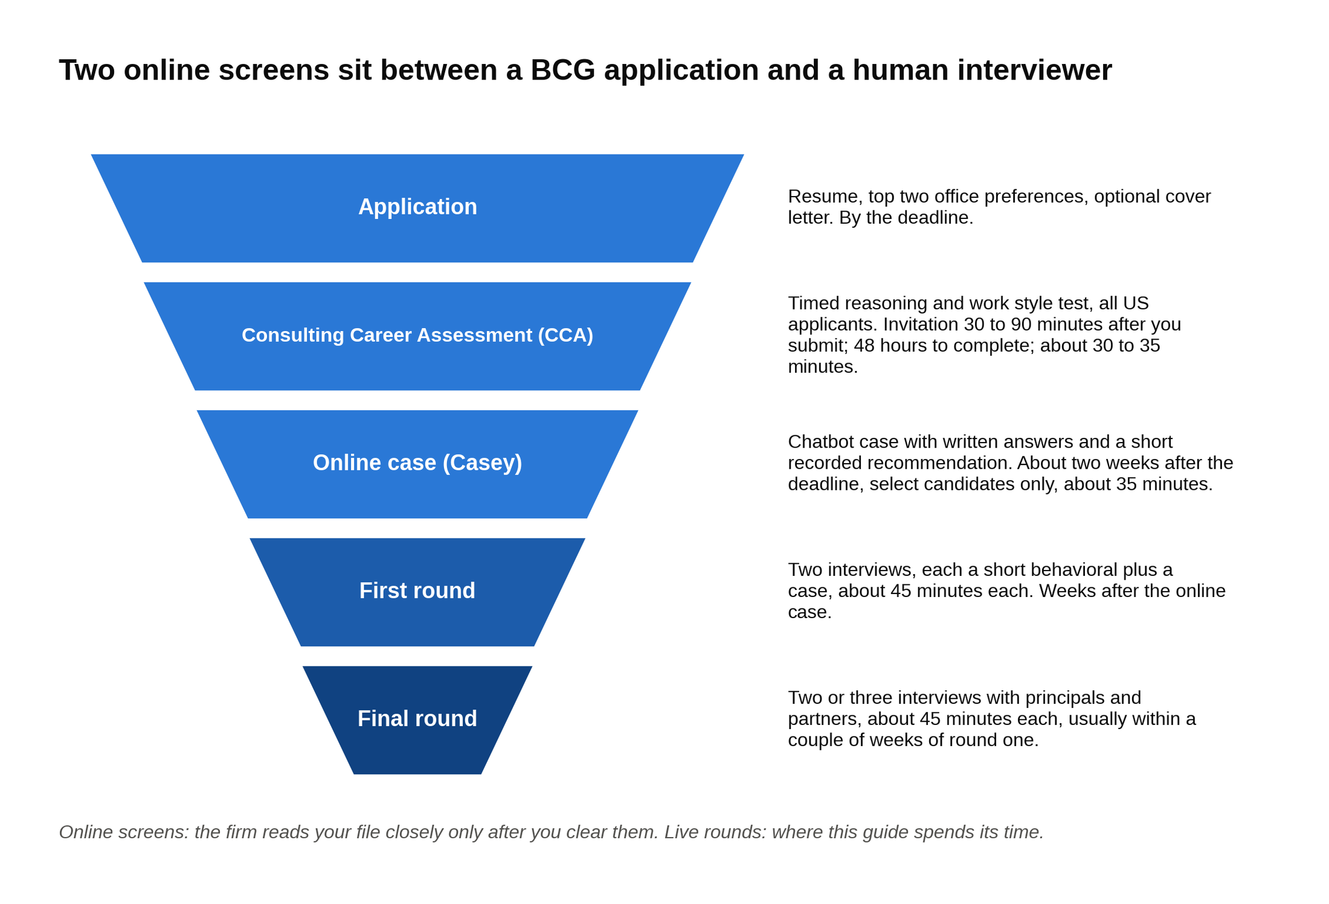
Two automated screens run before anyone at BCG reads your file closely, and the online case score you post is the one the firm keeps.

The CCA is the step most applicants take cold, because the invitation arrives before they've closed the laptop. It's a timed test with two kinds of questions: reasoning problems (numbers, logic, reading a short table) and work-style questions about how you'd behave on a team. Thirty to 35 minutes, one sitting, two days to start it. The timed reasoning section is where prepared candidates separate from unprepared ones, and the preparation is boring: timed practice sets in the week before you apply, not after. Our BCG online assessment guide walks through the format question type by question type, so I won't repeat it here.

The online case is the second filter, and it only reaches candidates who cleared the first. BCG calls it the online case. Most candidates call it Casey, after the chatbot that runs it. It presents one business problem, asks a mix of multiple-choice, number-entry and short written questions, and closes with a recommendation you record on video. One detail from BCG's own page matters more than any prep tip: candidates who have already taken the online case "will not be prompted to take it again." The online case score you post is the score BCG keeps, so a rushed attempt in one cycle can follow you into the next. Our Casey chatbot guide covers each question type and how the written answers are read.

Two other application facts straight from BCG's US page. Cover letters "are not required," though you can upload one under Other Documents, and I'd still write a short one if you've talked to someone at the firm. And you confirm your top two office preferences when you apply, so your networking should happen in those two offices before anywhere else.

Everything after the online case is live, and live is where this guide spends its time.

2. BCG tells you what it scores, if you read its own pages
Prep sites publish "BCG scoring rubrics" with point values. None of them trace back to BCG, and the firm has never published a case scoresheet. What BCG has published is more useful than a fake rubric, because it's the firm's own language for what it wants.

BCG's own interview page names five attributes it looks for: integrity, intellectual curiosity, creative thinking, a collaborative mindset, and drive. That list sits on BCG's interview process page, which also describes three interview types: a Skills Interview ("we will explore your experience, skills, and motivation for joining BCG"), a Case Interview, and, for client-facing roles, a Team Interview that assesses "problem-solving, analytical, and communication skills." For a US undergraduate the first two are what you'll meet, folded together into each 45-minute slot.

Here's how each attribute shows up inside a case, because none of them is abstract once you know what the interviewer is watching for:

- Integrity is whether you say "I made an arithmetic error, let me redo that" instead of talking past it. Interviewers catch the error either way. The candidate who owns it scores; the one who hopes it slides doesn't.
- Intellectual curiosity is the quality of your clarifying questions and whether you ask "why" about a number instead of just computing with it.
- Creative thinking is the non-obvious branch in your structure, or the second explanation you offer when the first one dies.
- A collaborative mindset is how you treat the interviewer: as a client you're thinking with, not a judge you're performing for. It shows when you take a hint gracefully.
- Drive is the push to a recommendation. Candidates who analyze beautifully and then wait to be asked "so what would you tell the CEO?" are missing it.

BCG's case preparation page adds a Do and Don't list. Do: listen actively, be yourself, think structurally, communicate clearly, clarify assumptions, show your thinking. Don't: panic under pressure, rush your response, overcomplicate solutions, ignore feedback, stay silent, interrupt. Two of those are specific to the candidate-led format. "Stay silent" is on the Don't list because in a BCG case silence is yours to fill. "Ignore feedback" is there because BCG interviewers do steer, lightly, when you're walking into a wall, and the candidates who don't register the nudge lose the round.

Debriefs from candidates who asked for feedback converge on five practical dimensions: structure, math under pressure, insight, communication, and composure when pushed. Notice what isn't there. Framework knowledge isn't scored. Getting the "right" answer isn't scored, since BCG's own page says there may not be one. The dimension that most often separates a final-round pass from a rejection is insight: two candidates compute the same number, and one of them says what it means for the client.

3. The first sixty seconds decide how the rest of the case feels
Go back to the scene this guide opened with, because it's the mechanic every BCG hire I've talked to describes. When the interviewer finishes the prompt, you have roughly a minute to turn a vague business question into a structure the two of you can work through together. Here's how to spend it.

Spend the first ten seconds repeating the problem back in one sentence, with the numbers, so you and the interviewer are solving the same case. "So the client is a 400-store pizza chain, revenue is up about 17 percent over two years, profit is down nearly 30 percent, and the CEO wants to know why and what to do." If you've misheard something, this is where it gets corrected for free.

Then ask one or two clarifying questions, not five. What counts as profit here (operating profit or something else)? Has anything structural changed (stores opened or closed, a new channel, an acquisition)? What does the CEO consider success? Clarifying questions are scored for curiosity, so make them questions whose answers would change your structure. "Is the client in the US?" rarely changes anything.

Then say: "Can I take a minute to structure my thoughts?" Every BCG interviewer expects this and every one of them says yes. Use the whole minute. Silence while you write is fine. Silence while you stare is not.

Build the structure from this client's economics, not from a memorized profit tree. A generic opening ("I'd look at revenue and costs") gets polite tolerance. A structure built from what the prompt told you changes the interviewer's posture immediately. Take a theme park whose profits fell while attendance held flat. Weak opening: "I'd break profit into revenue and costs and look at each." Strong opening: "Attendance is flat, so this isn't a volume problem at the gate. Three places the profit could have gone. Spend per guest inside the park fell, maybe because of a mix shift toward discounted tickets or lower food and merchandise spend. Costs per guest rose, most likely labor or maintenance on an aging ride base. Or the park is spending on something new, a ride or a hotel, that hasn't paid back yet. Per-guest spend data would tell us fastest, so I'd start there." Same thirty seconds of airtime. The second candidate sounds like a consultant because the structure contains a guess about this park.

Then pick the branch you'd open first and say why. That "why" is the hypothesis, and the next section is about it. For now, the rule: In a candidate-led case, a wrong path you notice and correct out loud beats a right path the interviewer had to point you toward. The interviewer will let you walk down a dead end for a while. Noticing it yourself ("the cost data looks flat, so my first hypothesis is wrong; let me go to revenue per guest") is one of the highest-scoring moments in the interview.

If you want the ground floor on what a case is before going further, our guide to what a case interview is covers the five case types and the basic structures. The rest of this article assumes you've seen a case before.

4. Hypothesis-driven means you say what you expect before you look
"Hypothesis-driven" is the phrase every BCG prep resource uses and almost none of them explain. Here's what it means in plain words.

A hypothesis in a case is a specific guess about the cause of the client's problem, stated out loud, before you've seen the data. Not "profit fell because revenue or costs changed." That's a definition, not a guess. A hypothesis sounds like: "My guess is the chain's growth came through third-party delivery apps, and the commissions on those orders are eating the margin." It names a cause, it implies which data you need first (orders by channel, cost per order by channel), and it can be proven wrong.

A hypothesis is useful because it tells you what to ask for first, and in a candidate-led case choosing what to ask for is the job. Without one, you ask for everything in the order the tree lists it, and you run out of time in the costs branch while the answer sat in revenue mix. With one, you go straight at the most likely cause, confirm or kill it in two numbers, and move.

Here's the cycle, step by step:

- State the hypothesis after your structure. "I'd start with revenue by channel, because my hypothesis is that growth came from a low-margin channel."
- Ask for the data that would test it. "Do we have orders and cost per order by channel for both years?"
- Do the math on what you're given, out loud, cleanly.
- Say the so what. What does this number mean for the hypothesis and for the client?
- Update. Either "that confirms it, so the next question is what to do about it," or "that kills it, so my next hypothesis is X, and I'd want Y to test it."

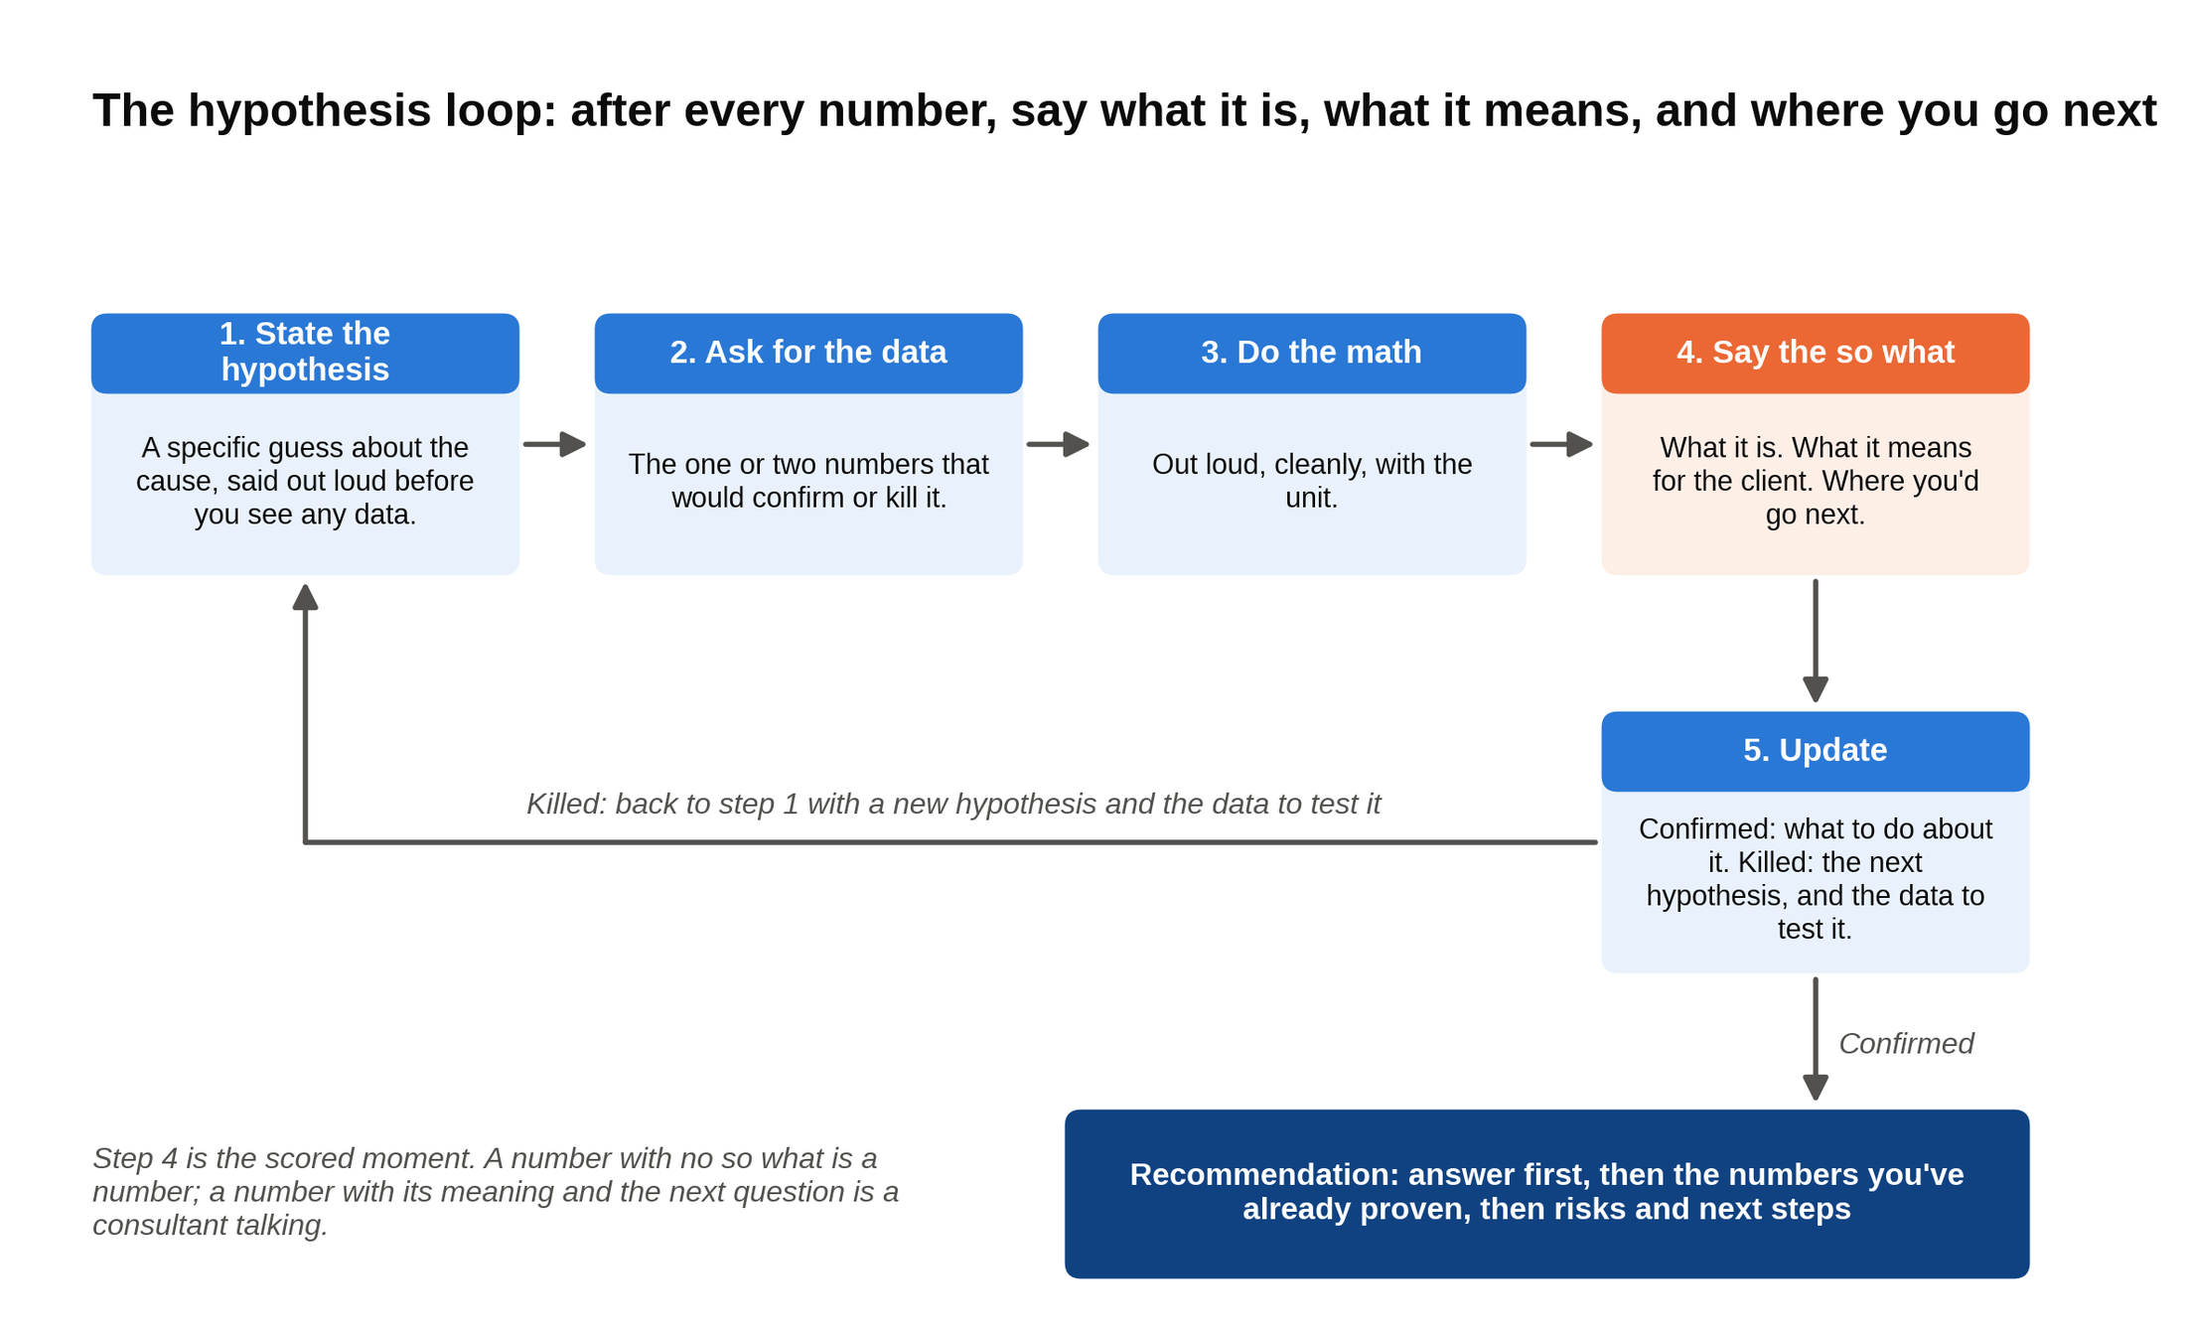
Every number you compute goes through step four before you move, and a killed hypothesis sends you back to the top with a new one.

Step four is the habit that separates BCG offers from BCG rejections, so it gets its own rule. After every number you calculate, say three things: what it is, what it means for the client, and where you'd go next. A candidate who computes "revenue grew 17 percent" and stops has given the interviewer a number. A candidate who says "revenue grew 17 percent, which rules out a demand problem and makes this a margin problem, so I want to look at contribution by channel" sounds like a consultant. Same arithmetic. One of them gets the follow-up question that leads somewhere.

It helps to know this is the firm's native way of thinking, not an interview affectation. BCG was built on a testable claim. In the 1960s Bruce Henderson, who founded the firm, argued that a company's unit costs fall by a predictable 20 to 30 percent every time its cumulative production doubles, and BCG published it as The Experience Curve in 1968. It's a hypothesis you can take to the data and confirm or kill. That's what a BCG interviewer wants from you in miniature, nearly sixty years later, across a table.

5. A full BCG case interview, worked from prompt to recommendation
This is my case, written in BCG's style, not a BCG case. It's a profitability case with the digital-channel twist BCG's book of business makes common. Every number below was built in a spreadsheet first and ties.

The prompt

"Our client runs about 400 pizza restaurants in the eastern US. Over the last two years, revenue grew about 17 percent, but operating profit fell by nearly 30 percent. During that time the chain launched its own ordering app and also joined the major third-party delivery platforms. The CEO wants to know what happened and what to do about it."

The clarifying questions

A strong candidate asks three, each one of which changes the structure:

- "When you say operating profit, is that after store-level costs and corporate overhead, before interest and tax?" Yes.
- "Did the store count change?" No, about 400 both years, no major openings or closures.
- "Is the CEO's goal to restore the old profit level, or to keep growing revenue while fixing margin?" Both, but margin first; the board is unhappy about profit.

The structure and the opening hypothesis

"Profit is revenue minus costs. Revenue grew, so the problem is in costs or in the margin on the new revenue. I'd split it three ways. First, the mix of orders across channels, since the chain added two new ways to order and each channel probably earns a different margin. Second, cost per order, since food inflation has been real. Third, fixed costs, since an app launch costs money before it earns any.

My hypothesis is the first one: the growth came through third-party delivery apps, which charge the restaurant a commission on every order, so the chain added a lot of revenue at a much thinner margin. If that's right, revenue by channel and cost per order by channel will show it. Can I see that?"

The interviewer hands over the exhibit.

The exhibit

 | Two years ago | Last year
In-store and carryout orders | 20 million | 14 million
Own-app delivery orders | 6 million | 5 million
Third-party app delivery orders | 4 million | 13 million
Average in-store ticket | $20 | $21
Average delivery ticket (both delivery channels) | $25 | $26
Food, packaging and store labor per order (all channels) | $12 | $13
Own-app delivery: driver cost per order | $4 | $4
Third-party apps: commission | 30 percent of ticket | 30 percent of ticket
Fixed costs (rent, salaried staff, marketing, corporate, app development) | $166 million | $175 million

The math, with the so what after every number

Step one: say what the exhibit shows before touching a calculator. "Total orders went from 30 million to 32 million, so volume is up a little. But in-store orders fell by 6 million and third-party orders rose by 9 million. The chain didn't grow much. It moved. That's consistent with my hypothesis, and now I need the margin on each channel to size it."

Step two: contribution per order by channel. Contribution means what's left from one order after the costs that order directly causes. Say it out loud as you compute:

- In-store, two years ago: $20 ticket minus $12 cost = $8 per order. Last year: $21 minus $13 = $8. Price rises covered food inflation, so the in-store margin per order held.
- Own-app delivery, two years ago: $25 minus $12 minus $4 driver = $9. Last year: $26 minus $13 minus $4 = $9. Also held.
- Third-party apps, two years ago: 30 percent of $25 is $7.50 commission, so $25 minus $12 minus $7.50 = $5.50. Last year: 30 percent of $26 is $7.80, so $26 minus $13 minus $7.80 = $5.20.

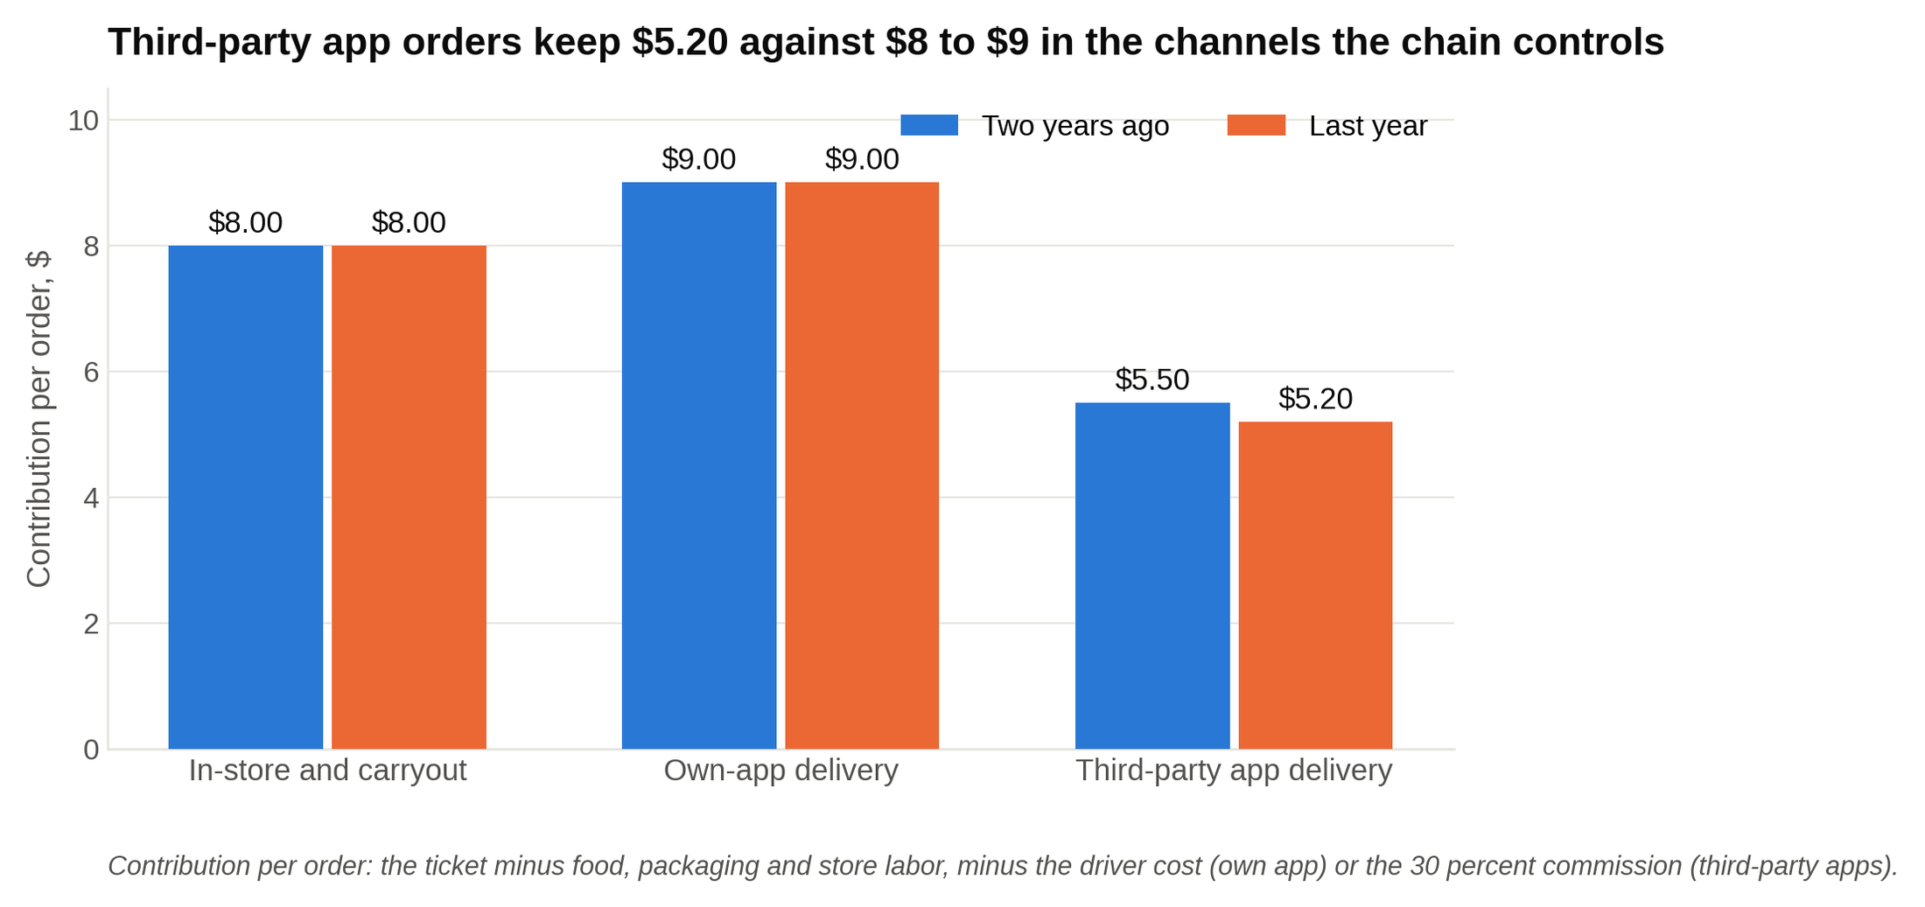
Contribution per order held at $8 in store and $9 on the chain's own app while the third-party channel that grew earns $5.20.

So what: "The two channels the chain controls earn $8 and $9 an order. The channel that grew earns $5.20. Every order that moves from the counter to a third-party app gives up about $2.80 of contribution, and a third-party order keeps only 20 cents of every dollar, versus 38 cents in store." That last comparison is the sentence the interviewer is waiting for. Say it before they have to ask.

Step three: total contribution by year.

- Two years ago: 20 million times $8 = $160 million, plus 6 million times $9 = $54 million, plus 4 million times $5.50 = $22 million. Total $236 million.
- Last year: 14 million times $8 = $112 million, plus 5 million times $9 = $45 million, plus 13 million times $5.20 = $67.6 million. Total $224.6 million.

So what: "Contribution fell by about $11 million even though the chain sold 2 million more pizzas. The growth was unprofitable growth."

Step four: tie it to the profit the CEO quoted. Two years ago: $236 million minus $166 million fixed = $70 million. Last year: $224.6 million minus $175 million = $49.6 million. That's a drop of about 29 percent, which matches the prompt. Revenue check: two years ago 20 times $20 plus 6 times $25 plus 4 times $25 = $650 million; last year 14 times $21 plus 5 times $26 plus 13 times $26 = $762 million, up about 17 percent. Also matches.

So what: "Of the roughly $20 million profit decline, about $11 million is channel mix and about $9 million is fixed costs, mostly the app build. The mix problem is bigger and it's structural, because it recurs every year. The fixed-cost piece is closer to one-time. So the recommendation should focus on channel economics."

Step five: a bridge, if the interviewer wants precision. In-store volume loss: 6 million orders times $8 = minus $48 million. Own-app loss: 1 million times $9 = minus $9 million. Third-party gain at the old $5.50: 9 million times $5.50 = plus $49.5 million. Third-party margin slip: 13 million times 30 cents = minus $3.9 million. Net: minus $11.4 million, which ties to the $236 million to $224.6 million drop. One more number that lands hard: the commission bill went from 4 million times $7.50 = $30 million to 13 million times $7.80 = $101.4 million. The chain is now paying its delivery platforms more than $100 million a year, which is twice its operating profit. That's the sentence a partner remembers.

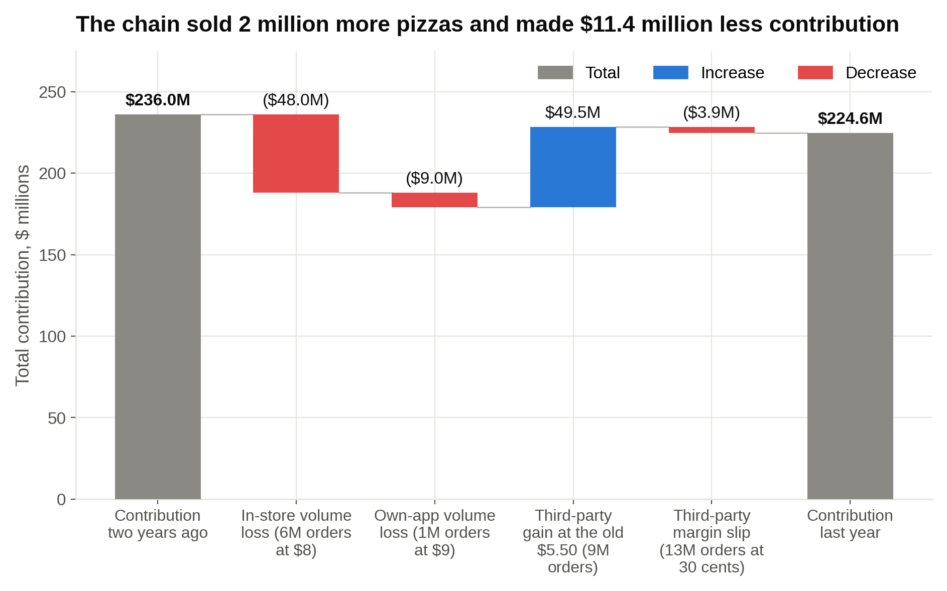
Orders moved from the counter to third-party apps, and the bridge from $236 million to $224.6 million shows the margin leaving with them.

The follow-up math

This is where BCG adds the quick-math check the firm is known for. The interviewer says: "Suppose the client could get half of its third-party orders to move onto its own app at the same ticket. What's that worth?"

Half of 13 million is 6.5 million orders. Each one goes from $5.20 to $9 of contribution, a gain of $3.80. 6.5 million times $3.80 = $24.7 million a year.

So what, in the same breath: "That assumes every one of those customers follows us to our app. Some won't. Third-party app users are often browsing the platform, not looking for us. If 20 percent of those orders disappear instead of moving, we keep 5.2 million orders at a $3.80 gain, which is about $19.8 million, and we lose 1.3 million orders at $5.20 each, about $6.8 million. Net gain about $13 million. Still worth doing, but roughly half the first number, and the plan has to earn the migration with something, like app-only pricing or a loyalty program."

The pricing twist

A strong candidate raises this unprompted; an interviewer sometimes hands it over. "What if the client priced its menu higher on the third-party apps to cover the commission, the way many chains do?"

Take the third-party ticket from $26 to $30, about 15 percent higher. Commission becomes 30 percent of $30 = $9. Contribution: $30 minus $13 minus $9 = $8 per order. That's the same $8 the in-store channel earns. Across 13 million orders, the gain versus today's $5.20 is $2.80 times 13 million = $36.4 million a year if volume holds.

So what: "Pricing the commission into the third-party menu makes every channel earn about $8 an order, which is the cleanest fix on the table. The risk is volume. Breakeven: today's third-party channel earns 13 million times $5.20, about $67.6 million. At $8 an order we'd need 8.45 million orders to match it, so the client could lose up to about 35 percent of its third-party orders before the price move left it worse off. That's a wide margin of safety, but it's still a guess until we test it. I'd pilot it in 40 stores for a quarter and measure before rolling it out."

The recommendation

Answer first, then reasons, then risks, then next steps. Delivered in about 60 seconds:

"Your profit fell because growth came through third-party delivery apps, which earn you about $5 an order against $8 to $9 in the channels you control. In-store orders fell by 6 million while third-party orders tripled, so contribution dropped by about $11 million even as revenue grew, and your commission bill passed $100 million a year. I'd do three things. First, price the third-party menu about 15 percent above in-store, which brings that channel's margin to roughly $8 an order and is worth up to $36 million a year, with a pilot in 40 stores to measure volume loss. Second, move repeat customers onto your own app with app-only pricing and a loyalty program; even if only four in five migrate, that's worth about $13 million a year. Third, hold fixed costs flat now that the app is built. Together those steps more than recover the lost $20 million. The main risk is losing third-party customers who never knew your brand, so we'd watch order volume weekly during the pilot."

Two things about that close. It opens with the answer, not with "so, to summarize what we found." And every number in it was computed earlier in the case, so the interviewer has already agreed to each one. A strong BCG recommendation contains no new analysis, only the numbers you've already proven, arranged so a CEO could act on them.

Where an average candidate loses points on this case

- Structure that's a profit tree with no guess attached. The hypothesis is what gets you to the exhibit in two minutes instead of eight.
- Reading the exhibit by computing immediately. Say what it shows first (orders moved, not grew).
- Computing $5.20 and waiting. The so what ("two orders in five now earn 20 cents on the dollar") is the scored moment.
- Blaming food inflation. The exhibit shows price rises covered it, and a candidate who checks that before blaming it looks careful.
- Answering the follow-up with $24.7 million and no caveat. BCG math questions almost always have a "yes, but" the interviewer is waiting for you to find.
- A recommendation that starts with the analysis instead of the answer.

6. BCG's math bar runs higher, and twenty minutes a day covers it
Candidates consistently report more quick-math checks and brainteaser-style sub-questions at BCG than at McKinsey or Bain. Mid-case, expect something like "quick, is that bigger or smaller than the client's whole profit?" with ten seconds to answer. The case content you can't predict. The math you can.

The math a BCG case asks for is a short list of operations, and you can drill every one of them without a partner. Here's the list, with the technique for each:

- Percent of an odd number. 30 percent of $26: take 10 percent ($2.60) and triple it ($7.80). 15 percent: take 10 percent and add half of it again.
- Large multiplications with units. 13 million times $5.20: 13 times 5 is 65, 13 times 0.2 is 2.6, total 67.6 million. Always say the unit.
- Percent change. $70 million to $49.6 million: the drop is $20.4 million, and 20.4 over 70 is a bit under 30 percent (because 21 over 70 would be exactly 30).
- Breakeven. If a change raises contribution per order from $5.20 to $8, how many orders can you lose? New orders needed equals old total divided by new unit: 67.6 over 8 is 8.45 million, against 13 million today, so about 35 percent.
- Sanity checks. Before you say a number, compare it to one you already know. "A $36 million gain against $50 million of profit is huge, so I'd want to pressure-test the volume assumption." Interviewers score the comparison as much as the arithmetic.

Twenty minutes a day for the month before interviews is enough. Two-digit multiplication in your head, percentages of awkward numbers, dividing by 12 and by 52, and one breakeven a day. A student I worked with through WSG, call her M, drilled on her commute for five weeks before her BCG rounds; her feedback flagged quantitative confidence specifically, and she signed. Nobody has ever told me their BCG math was too fast.

Keep a small labeled table of every number you compute, because BCG's follow-up questions ask for numbers you've already found. Candidates who've been through final rounds swear by this. When the follow-up comes ("what was contribution per third-party order again?"), you look down instead of recomputing, and the interviewer watches you stay calm.

7. Expect one of five case types, each with a BCG tilt toward technology and transformation
Every major firm's case library is built on five case types: profitability, market entry, M&A, operations and cost, and market sizing. BCG's versions lean harder into technology, data and transformation angles than its rivals', which tracks the firm's actual book of business. A profitability case becomes "margins are falling while we fund a digital rollout," like the pizza case above. A market entry case becomes a platform question. An operations case becomes an automation question.

BCG's three published interactive cases show the tilt directly, and you should work all three before your first live mock. They live on BCG's quiz site, not its main careers page, and each one teaches something different:

- The Climate Case Challenge: a global personal-care company wants a business case for a science-based emissions target. Strategy under a constraint, with the math built around which initiatives cut the most carbon per dollar.
- The customer satisfaction case: a two-year-old digital bank launched as number one in customer satisfaction and has slipped to sixth; the new CEO wants back into the top three. A digital turnaround built around which journeys to fix first.
- The IT architecture case: a 30,000-person consumer goods company upgrading its ERP system has to migrate to the cloud as part of the upgrade. Pure technology economics.

BCG also links a free job simulation called OneDay@BCG from its case prep page. It's a day-in-the-life exercise rather than a scored case, and it's the single best source of specific material for your "why BCG" answer, because you can talk about a problem you worked rather than a value you read.

Then build your own structures for the case in front of you. Interviewers at all three MBB firms flag a memorized framework within a minute, and BCG's candidate-led format exposes it fastest because nobody rescues you from your own template. Our breakdown of seven case frameworks and when to use them is the right level: know the building blocks, then assemble them for this client.

There's an irony here that BCG interviewers enjoy. The most famous framework in business school is the firm's own growth-share matrix, the two-by-two that sorts a company's businesses into stars, cash cows, question marks and pets. Bruce Henderson popularized it in a 1970 essay called The Product Portfolio, and BCG's own history page says that at its peak about half of all Fortune 500 companies used it. Don't bring it to a BCG interview. A matrix built for allocating cash across a conglomerate's divisions has nothing to say about a pizza chain's delivery commissions, and reaching for it tells the interviewer you're sorting the case into a box instead of thinking about it.

8. The behavioral half is shorter than McKinsey's PEI, and it decides the close calls
Each BCG interview opens with 10 to 15 minutes of behavioral questions before the case. That's less airtime than McKinsey gives its Personal Experience Interview, so candidates treat it as a warm-up. It isn't. Behavioral answers move BCG decisions at the margin, because by the final round every remaining candidate can case. Case performance clusters tightly at that stage. The story that makes a partner want you on a client site is what separates two candidates with the same case score.

Prepare one story for each of BCG's five attributes from section two: integrity, intellectual curiosity, creative thinking, collaborative mindset, drive. Five stories, each with a specific setting, a decision you made, what happened, and a number. You won't tell all five. You'll be asked two or three variants of "tell me about a time you led," "tell me about a conflict on a team," "tell me about something you built," and you'll pick from the five. Our guide to breaking into MBB covers the behavioral side across all three firms in more depth.

Then there's "why BCG," which every interviewer asks and most candidates answer with the firm's website. Three facts give you better material, and all three are true.

BCG started in 1963 as a one-man consulting division inside a bank, the Boston Safe Deposit and Trust Company. Henderson had left Harvard Business School 90 days before graduation to join Westinghouse, spent 18 years there, and was recruited to start the division at 48. The division billed $500 in its first month, made its first consultant hire that December, and was formally named the Boston Consulting Group in 1968, when it had 36 employees [VERIFY: founding details against BCG's history page and Henderson biographies]. The firm that grew out of it reported $14.4 billion of revenue for 2025, its 22nd straight year of growth, with AI and tech work now more than 40 percent of revenue, per BCG's own April 2026 release [VERIFY: latest annual figures]. If the digital side is your angle, that last number is worth using, because it's true and most candidates don't know it.

A strong "why BCG" names one thing you did and one conversation you had, not a ranking. The OneDay@BCG simulation and one of the three practice cases give you the first. A 15-minute call with an Associate in one of your two preference offices gives you the second.

9. The Summer 2028 calendar: applications land in 2027
BCG now fills its junior-summer Summer Associate class about 15 months ahead, so the application you care about as a sophomore is really the junior internship, applied for in sophomore spring. BCG's US page currently reads "Applications for our 2027 Summer Internship and Full-Time opportunities have closed," and the Summer 2027 deadline was June 2, 2026, for students graduating in 2028 [VERIFY: June 2, 2026 via Yale OCS and Management Consulted; BCG US Associate page]. The next cycle is the one this guide is written for.

What | Who | When to expect it | Status on October 1, 2026
Summer Associate internship, Summer 2028 | Students graduating around spring 2029 (sophomores now) | Applications expected in the first half of 2027, single deadline likely late spring [VERIFY: Summer 2028 window and deadline on BCG's US Associate page] | Not yet posted
BCG Launch (virtual info series, not a job) | Undergraduates and non-MBA master's students in the US and Canada, all backgrounds | Registration opens closer to the sessions; the 2026 portal closed May 29 [VERIFY: 2027 Launch dates] | 2026 edition closed
BCG Embark (virtual conference inside Launch) | 2026 edition: students graduating December 2027 to July 2028, open to all backgrounds; selected from the Launch pool, no separate registration | 2026 edition: register by April 15, event May 14 [VERIFY: 2027 Embark dates and graduation range] | 2026 edition closed
Growing Future Leaders (sophomore summer internship) | Historically sophomores from specific underrepresented backgrounds | Past cycles closed mid-September [VERIFY: whether BCG posts a fall 2026 or 2027 cycle] | GFL link on careers.bcg.com serves the generic campus page; no live posting
Full-time Associate, start 2029 | Students graduating 2029 | Last cycle's full-time deadline was July 7, 2026 [VERIFY: pattern for the 2028 full-time window] | Not relevant until junior summer ends

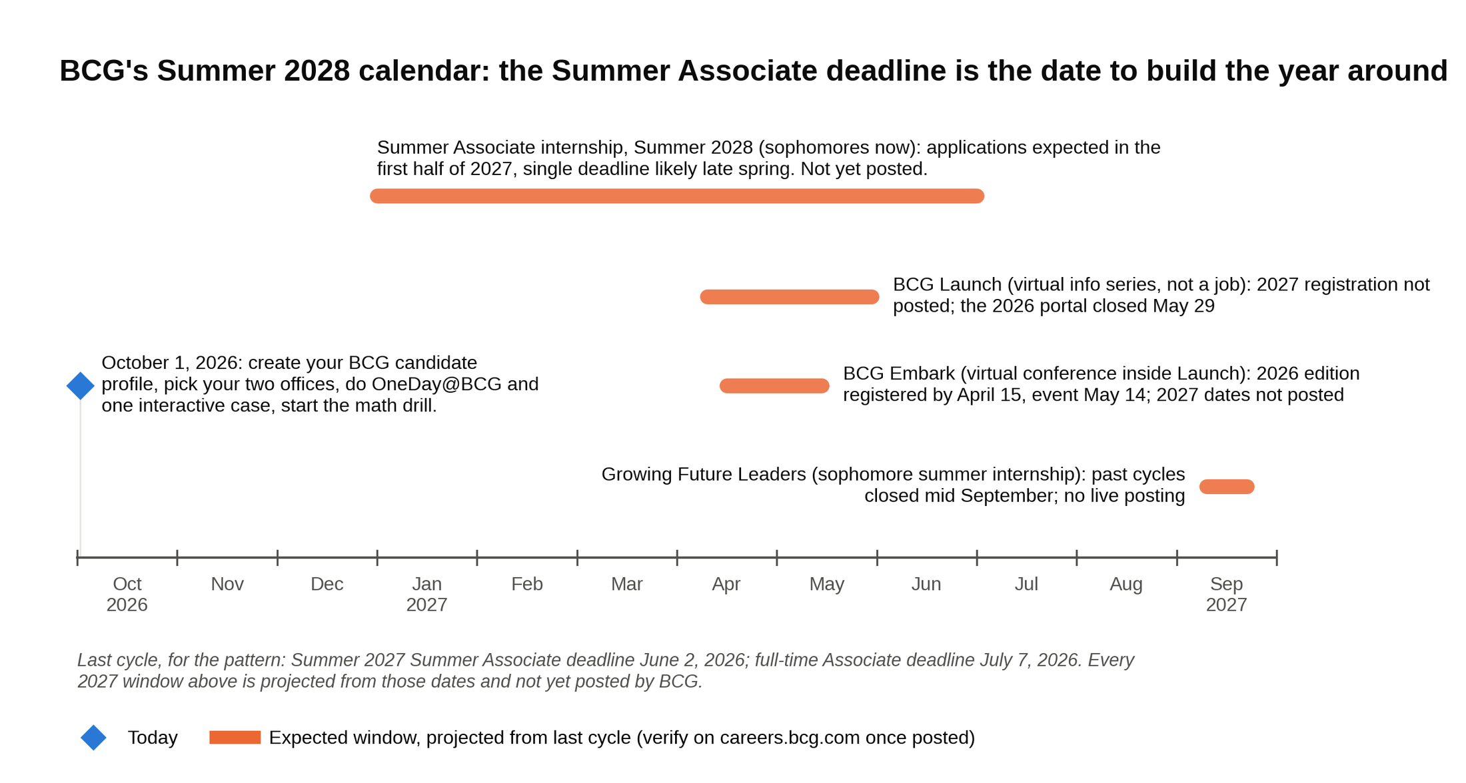
Nothing on BCG's 2027 calendar is posted yet, so plan around a late spring Summer Associate deadline and treat Launch and Embark as useful extras.

The Summer Associate deadline is the date to build your year around, because it's the one that's sure to exist. Launch and Embark are useful, not required, and neither is a job application. GFL may or may not return. Bridge to BCG is for PhDs, MDs and JDs, not undergraduates, so don't spend an evening on it. For the sophomore-program picture in full, including what BCG has and hasn't confirmed, read our BCG internship guide.

If you're a freshman, run the same plan one cycle later: your Summer Associate window would be spring 2028 for Summer 2029. If you're a junior who missed the June 2026 deadline, your next BCG entry is the full-time Associate application, which in the last cycle closed in early July for the following year's start [VERIFY: full-time deadline for 2028 start]. Tier 2 and Big 4 strategy firms often recruit later for the same summers, so a junior still has options worth checking this fall for Summer 2027 outside MBB.

The seat you're working toward: US Associate base pay in the $110,000 to $115,000 range, a $5,000 signing bonus, and a performance bonus that salary trackers put anywhere from $15,000 to $30,000 depending on the year and the source [VERIFY: current-year comp against Management Consulted and BCG offer letters]. Summer Associates have been paid about $21,000 for the ten-week internship in recent cycles [VERIFY: current Summer Associate pay]. BCG doesn't publish pay, so every Associate comp figure you read online is a tracker's estimate, not an offer.

10. A four-week BCG case interview prep plan
Four weeks is the minimum I'd give a student who has never done a case. If you have more time, stretch weeks two and three. If you've cased before, compress week one. Twelve to fifteen live, candidate-led mocks over four weeks is the range our successful BCG candidates report; fewer than eight and the structure still wobbles under silence.

Week one: foundations. Read BCG's interview and case prep pages once, for the five attributes and the Do and Don't list. Do the OneDay@BCG simulation and one of the three interactive cases. Start the daily math drill (20 minutes, every day, through week four). Learn the five case types and the two or three building blocks for each. Do two cases out of a book, reading the solution only after you've written your own structure.

Week two: structure and hypothesis. Every day, take one prompt and give yourself 90 seconds to write a structure and state a hypothesis out loud, with no partner. Ten prompts, ten structures. Then review: does each structure contain a guess about this client? Would each hypothesis tell you which data to ask for first? Finish BCG's other two interactive cases. Do your first two live cases with a partner, even if they're rough.

Week three: live, candidate-led, with a silent partner. Four to six live cases this week. Tell your partner to say nothing after reading the prompt until you ask for something specific. Have them hand you an exhibit and stay quiet while you read it. After every number, practice the three-part so what: what it is, what it means, where you go next. Record one session and listen for the silences you didn't fill with thinking out loud. Also this week: two timed CCA-style reasoning sets and one timed online case run-through, so neither screen is new when the real invitation lands.

Week four: final-round shape. Two or three cases a day, two days, with a partner who interrupts you, pushes back on your math, and asks "so what would you tell the CEO?" when you pause. Write your five behavioral stories and say each one out loud in under three minutes. Have one person ask you "why BCG" cold. Taper the math drill to ten minutes. Confirm your interview logistics. The day before, do nothing. Resting is part of the prep.

One habit to run all four weeks. After each mock, write the one-sentence recommendation you should have opened your close with. Writing the answer-first sentence after every practice case is the fastest way to shorten your closes, and the close is what BCG grades hardest at the end. Over twenty cases you'll watch that sentence get shorter and more specific.

Say this, don't say that in a BCG case interview
Opening the case, after the prompt
Don't say: "I'd look at revenue and costs to see where the problem is."
Say: "Revenue grew, so this is a margin problem. My hypothesis is the growth came through a low-margin channel. I'd start with orders and cost per order by channel, because that would confirm or kill it fastest."

After the interviewer hands you an exhibit
Don't say: "Okay, let me calculate." (Then silence for two minutes.)
Say: "Before I calculate, the exhibit shows orders moved rather than grew: in-store down 6 million, third-party up 9 million. Now I'll work out what each channel earns per order."

After you compute a number
Don't say: "So third-party contribution is $5.20 per order." (Then wait.)
Say: "Third-party earns $5.20 against $8 in store, so two orders in five now keep 20 cents on the dollar instead of 38. That's the margin leak, so the next question is whether we can move those orders or reprice them."

When your first hypothesis dies
Don't say: "Hmm, okay. So, um, maybe costs?"
Say: "That kills my first hypothesis; cost per order held flat. My second is fixed costs from the app build, and I'd want the fixed-cost line for both years."

When the interviewer asks a quick-math question
Don't say: "About $25 million." (Correct, and finished.)
Say: "About $25 million if every order migrates. Realistically some won't, so call it $13 million at an 80 percent migration rate, and the plan has to earn that migration with app-only pricing."

Closing the case
Don't say: "So to summarize, we looked at channels, then costs, then..."
Say: "Your profit fell because growth came through a channel that earns $5 an order instead of $8. I'd reprice the third-party menu, move repeat customers to your app, and hold fixed costs. Together that recovers more than the $20 million you lost. The main risk is volume loss, so I'd pilot in 40 stores first."

Why BCG?
Don't say: "BCG's collaborative culture and intellectual rigor really appeal to me."
Say: "I did the climate practice case and then talked with an Associate in your Chicago office about a decarbonization study she'd worked on. Half her week went to testing the client's own assumptions, and that's the work I want."

What to do this week
Sophomores: create your BCG candidate profile, pick your two offices, and put a placeholder for the Summer 2028 Summer Associate deadline on your calendar for late spring 2027 [VERIFY: once posted]. Then do the OneDay@BCG simulation tonight and one interactive case this weekend. Juniors who missed the June window: start the math drill anyway, because the full-time cycle uses the same case and the same five attributes.

Everyone: book your first live case for ten days out, and tell your partner one thing in advance. When they finish reading the prompt, they should set it down, say "so, how would you approach this?", and not say another word until you ask for something. That minute of silence is the BCG case interview. The candidates who pass it decided weeks earlier what they'd do with it.

